Key to bringing technology and guidelines together to create accessible user experiences are people. Everybody involved in the Software Development Life Cycle (SDLC) has a role to play:
- Product owners, and organizations, have a responsibility to mandate and resource teams to create accessible products
- Developers are responsible for authoring content that follows technology specifications and accessibility guidelines
- User experience professionals and designers are responsible for creating accessible layouts, images, presentation, features and user journeys as well as carrying our user research and usability testing with people with disabilities
- Content editors are responsible for content strategy, text, equivalent alternatives for non-text content and other general text elements presented in the pages
- Quality assurance and testers are responsible for checking for compliance with standards and guidelines using a combination of evaluation tools, assistive technologies, and manual testing
QUICK CHECKLIST
Quick Checklist for Comms and IT team
Navigation
• [ ] Add table of contents
• [ ] Add skip-to-content link
• [ ] Add back-to-top button (only for long pages)
• [ ] sidebar for multi pages (left side). Place the main content before the sidebar in the HTML code.
Structure
• [ ] Apply correct heading hierarchy
• [ ] Break content into sections
• [ ] Date used should be in this form 12 Feb 09 and not 12/02/09
• [ ] Placeholder should be meaningful
Links & Downloads
• [ ] Replace all undescriptive links with descriptive links. – Instead of Read more or Click more it should be the post name (Eg. Moderator - Full story) – All Links should be meaningful
• [ ] Label PDFs with type + size
• [ ] Provide HTML alternatives when possible.
• [ ] All images should have description below it

Visual Accessibility
• [ ] Ensure high contrast
• [ ] Ensure text is resizable to 200%

Body text: Font: Arial. Size 13.5 or 14px
• Headings:
• Page title: H1: 32–40px
• H2: 24–32px
• H3: 20–24px
• H4: 18–20px
• Buttons and UI labels: 16px minimum
• Captions or footnotes: 14px minimum

It should work with the below principle POUR

Perceivable

Conformance of News Page to WCAG 2.0 - Perceivable
 | # | Title | Description | Result
 | 1.1 | Text Alternatives | Provide text alternatives for any non-text content so that it can be changed into other forms people need, such as large print, braille, speech, symbols or simpler language.
 | 1.2 | Time-based Media | Provide alternatives for time-based media.
 | 1.3 | Adaptable | Create content that can be presented in different ways (for example simpler layout) without losing information or structure.
 | 1.4 | Distinguishable | Make it easier for users to see and hear content including separating foreground from background.
Operable

Conformance of News Page to WCAG 2.0 - Operable
 | # | Title | Description | Result
 | 2.1 | Keyboard Accessible | Make all functionality available from a keyboard.
 | 2.2 | Enough Time | Provide users enough time to read and use content.
 | 2.3 | Seizures | Do not design content in a way that is known to cause seizures.
 | 2.4 | Navigable | Provide ways to help users navigate, find content and determine where they are.
Understandable

Conformance of News Page to WCAG 2.0 - Understandable
 | # | Title | Description | Result
 | 3.1 | Readable | Make text content readable and understandable.
 | 3.2 | Predictable | Make Web pages appear and operate in predictable ways.
 | 3.3 | Input Assistance | Help users avoid and correct mistakes.
Robust
Conformance of News Page to WCAG 2.0 - Robust
 | # | Title | Description | Result
 | 4.1 | Compatible | Maximize compatibility with current and future user agents, including assistive technologies.

Demo Website - Before and After Demonstration: Overview

Descriptive Text for images
This can include many types of images, such as:
    - Pictures of people, and places
    - Charts, diagrams, and other infographics
    - Buttons and other actionable objects
    - Decoration and illustrative images
Each of these needs a text alternative that conveys the purpose of the image. That is, the information that the image is communicating visually, or that function that it provides to the user.

Example 1: Pictures in context
The following picture of a young puppy probably only needs the text alternative "young puppy."

Yet depending on the context surrounding that picture, you might want to point out its color or that it has a bell attached to its collar.
Example 2: Functional images
The following is an image that contains text. Text alternatives need to include this text presented visually, in this case "Web Accessibility Initiative."

This image is also a logo. When it is used as a link to the homepage, the text alternative could be "Web Accessibility initiative homepage."
Example 3: Decorative images
Often images are used purely for visual decoration, and do not provide information or functionality. For example this visual separator used between paragraphs.
Such images need to have an empty text alternative. Doing this communicates to assistive technologies that it is safe to ignore this image - not that you forgot to add the text alternative.
- WAVE Web Accessibility Evaluation Tool
The WAVE tool can be used in different ways:
- Simply enter the location of the web page you want to test in the "Web page address" field and run
- You can also install browser extensions so that you can launch the tool directly from your browser
Activity - Check text alternatives
Go to the inaccessible NEWS Before Demo web page (remember that this page is intentionally inaccessible for learning purposes). Use the WAVE tool to check images on this page and answer the following questions:
- How many images are missing alternative text?
- How many linked images are missing alternative text?
- How many spacer images are missing alternative text?
Find the top_logo.gif image that looks like this:

🎥 Time-Based Media (WCAG 1.2)
Content like audio, video, or slideshows that depends on time must have accessible alternatives.
👉 Needed for people who:
- Cannot hear (audio)
- Cannot see (visuals)
- Cannot process content quickly

✅ 4 Key Alternatives
1. Captions and subtitles are not same
Text synced with video
👉 Includes dialogue + sounds (for Deaf users)
2. Transcripts
Full text version of audio + visuals
👉 Can be read instead of watching/listening
3. Audio Descriptions
Narration explaining visual details
👉 Helps people who cannot see the video
4. Sign Language
Interpreter shown in video
👉 Important for Deaf users who use sign language

🔑 Simple idea
Provide multiple ways to access the same content 👍
Activity - Check structure
Some browsers provide the option to turn off images and disable CSS from the menus. For example:
- In Opera:
  - View > Images > Show Images or, Alt+V, I, S
  - View > Style > User Mode or, Alt+V, S, U
- In Safari: If the Develop menu is not shown in the menu bar, turn it on:
  - In Safari preferences, click [Advanced].
  - Select the [Show Develop menu in menu bar] checkbox.
  - Develop > Disable Images or, Ctrl+F2, D, down arrow to [Disable Images]
  - Develop > Disable Styles or, Ctrl+F2, D, down arrow to [Disable Styles]

Distinguishable content
- Don’t rely on color alone
Use additional indicators (e.g., asterisks, labels), not just color like “red fields”.
- Provide sufficient contrast
Text should have at least 4.5:1 contrast ratio (ideally 7:1) for readability.
- Support content resizing
Ensure layouts don’t break when users zoom or increase text size.
- Give control over audio
Audio longer than 3 seconds must be pausable, stoppable, or adjustable.

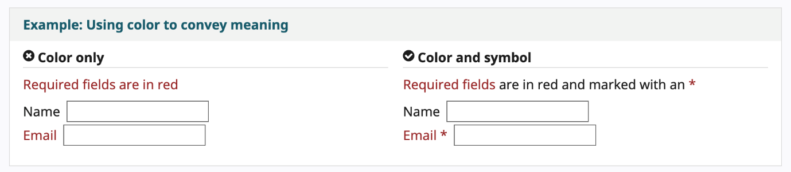

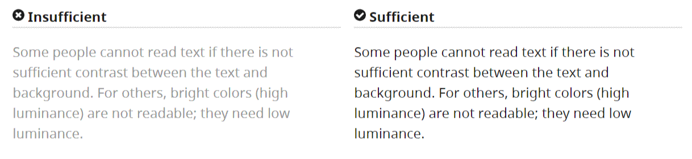

Checking contrast ratio
https://contrastchecker.com/
https://developer.paciellogroup.com/resources/contrastanalyser/

Activity - Check text resize
Increasing font size functionality is only available in the FireFox web browser.
- Set zoom to text only.
- From the menu bar, select View > Zoom > Zoom Text Only.
- Increase zoom to 200%.
- To incrementally increase zoom with the keyboard:
  - Windows, press Ctrl+[+] (hold down the control key and press the + key at the same time).
  - On Mac, press command+[+] (hold down the command key and the + key at the same time).
- Usually 4-6 key presses get to 200%.
- To check or set the zoom percent from the menu option:
  - Click the menu button.
  - Firefox customization menu zoom percent settings.
  - In the customization menu, click the + button to zoom larger. The number before the + button is the current zoom percent.
  - To confirm that you have a text-only zoom set from step 1, make sure that only the text is getting larger, not the images.

For accessibility guidelines (WCAG):

Normal text → at least 4.5:1
Enhanced readability → ideally 7:1
Large text & graphical objects → minimum 3:1

Activity - Check keyboard accessible
Use your own keyboard to navigate through and check any web page of your choice. Notice the behavior of video controls in particular!
- In a browser that supports keyboard navigation with the Tab key (for example, Firefox, IE, Chrome, and Safari; not Opera):
    - In Mac browsers, enable keyboard navigation to all controls. (In Windows browsers, you don't need to do this step.)
    - In newer browsers: Select System Preferences > Keyboard > Shortcuts. Select the "All controls" option button.
    - In older browsers: Select System Preferences > Keyboard > Keyboard Shortcuts. In the "Full Keyboard Access" section, check "All Controls".
- Click in the address bar, then put your mouse aside and do not use it.
- Press the Tab key to move through the elements on the page. You can press Shift-Tab to go backwards.
- To move within elements such as drop-down lists and menu bars, press the arrow keys.
What to check for:
    - Tab to all: Check that you can tab to all content including media player controls. (A common problem is that you cannot tab to media player controls.)
    - Tab away: Check that you can tab away from all elements that you can tab into. (A common problem is the keyboard focus gets caught in media controls and you cannot get out; it's called the "keyboard trap".)
    - Tab order: Check that the tab order follows the logical reading order (e.g., for left-to-right languages: top to bottom, left to right) in sequence.
    - Visual focus: Check that the focus is clearly visible as you tab through the elements, that is, you can tell which element has focus, e.g., links have a gray outline around them or are highlighted.
    - All functionality by keyboard: Check that you can do everything with the keyboard; that is, you don't need the mouse to activate actions, options, visible changes, and other functionality. (A common problem is that some functionality is available only with mouse hover, and is not available with keyboard focus.)
Activity - Check page titles
- Go to any search engine and do a search on any topic you are interested in.
- Review the search results page:
- Click on one of the search results links and compare the link text you just clicked on to the page title that you just landed on.
  - In your opinion, what was the best title on the first search results page?
  - What do you think made that title good?
- Repeat for several pages, and consider checking your own website.
Before we specifically consider approaches to developing skills, let's consider the roles that might be part of a web development team. Historically accessibility has often been considered the domain of the developer. However, all the people in a development team have a role to play. Sometimes people will have multiple or overlapping roles, and hence overlapping responsibilities for ensuring accessibility is considered and embedded.
Let's consider the common roles in a sustainable multidisciplinary team. The team has responsibility to design, build, operate and iterate digital services, led by a product manager with decision-making responsibility. The team, and their responsibilities for accessibility, would look like:
- product manager (product owner) - overall responsibility
- user researcher - ensuring people with disability are included
- interaction designer - considers the different ways people access the web
- graphic designer - color and contrast choices
- content author/designer - content structure and readability
- developer - semantic coding
- QA/tester - checks all good before release
In some teams, one person might have two roles, for example interaction design and graphic design. In this case the person would have increased accessibility responsibilities. Some organizations engage the services of an accessibility expert part-time, in addition to up-skilling themselves around digital accessibility, to help meet their commitment.
Recruitment
Often an organisation will have to recruit people to some of the positions needed to have an experienced team. Having accessibility knowledge and skills as part of the recruitment brief is essential.
An organization committed to digital accessibility will add a requirement to their recruitment policy that ICT staff have some knowledge and skills related to accessibility. The recruitment policy will also have some new-starter requirements to be sure all new ICT staff understand the organization's commitment.

