Congregational Resources
Volunteers
The following Volunteer policy and procedure applies across all areas of the UCA in Victoria and Tasmania.
Congregation employment
There are a number of obligations when employing paid workers including:
- Payment of minimum wages
- Providing payslips; and
- Recordkeeping
For information about minimum wages and other employment related obligations, please refer to the Fair Work Commission.
Paying employees
Contact Michelle Ennis on 9116 1933 for Central Stipends Payroll Service for assistance with setting up payments.
Policies & procedures
The template policies below are made available here as optional tools for congregational use.
Note that these templates are not specifically approved policies and are by no means mandatory.
Policies apply to congregation employees and are not applicable to ministerial roles.
Queries
For further information or advice contact People & Culture at people&culture@victas.uca.org.au.
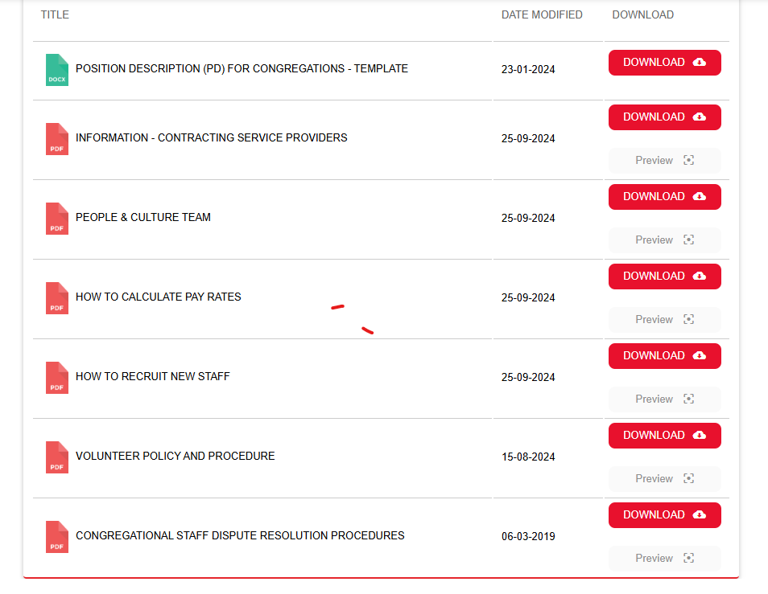
Fair Work information statement
Employers must provide every new employee a copy of the Fair Work Information Statement before, or as soon as possible after, they start their new job. The statement can be found at the following location:
Fair Work: Information statement
Related links
National Criminal History Checks
Working With Children
Fair Work: Employment Templates & guides
Fair Work: Employment Fact Sheets
Fair Work: Minimum wages & Pay Guides

